TMRP summary update

Project title: Photovoice to explore community members perspectives regarding health and healthcare challenges in Mukono District, Uganda.

Organisation: Makerere University School of Public Health

Abstract: There have been calls for a greater number of clinical studies in low- and middle-income countries (LMICs) to explore locally identified areas of concern, in order to ensure research studies are contextually relevant. One useful approach to help achieve this aim is Community Based Participatory Research (CBPR), which broadly involves local stakeholders being central to the research process. CBPR is often guided by the hypothesis that such an approach can help to ensure research remains contextually relevant, and helps to better understand the lived experiences of a community. Specific to clinical trials, CBPR has consistently been suggested as a means of diversifying participation, as well as increasing relevance and quality to end users (i.e. patients or community members). One method aligned to the CBPR paradigm is photovoice. In a photovoice study, cameras are given to individuals in order to capture photographic images around a central theme which is normally of community importance or concern. In our project, the subject of interest is exploring concerns and challenges related to healthcare in the community. To date 15 community members from the Seeta Nazigo Parish, Mukono District located in central Uganda have been selected to participate in the photovoice project. Participants have been provided with initial training in the use of cameras and have undergone one full round of photographic capture and image discussion with the project team.

Summary of progress: To date, we have made good progress in achieving the project goals. The team have submitted and received ethical approval for the study from Makerere School of Public Health Research Ethics Committee and the Ugandan National Council for Science and Technology (UNCST). In addition, we have successfully procured all of the items needed for the study, recruited, consented and trained all 15 community participants, and held one full round of interviews following the first phase of the photography process. We have also held monthly team meetings where all of the project researchers have been present, and recently updated the TMRP team with our progress at an update meeting in December 2020.

Challenges: We have encountered several challenges which resulted in a slight delay to the start of the project. Firstly, we had difficulties in procuring cameras and solar chargers for the project. The initial plan had been for Dr O’Donovan to purchase the cameras in the UK and bring these to Uganda. However, due to travel restrictions as a result of COVID-19, Dr O’Donovan was unable to fly to Uganda. Despite this initial challenge, we nonetheless managed to procure cameras within the project budget in Uganda, allowing us to move ahead with the project. The second issue concerns the project finances being sent to the wrong account at Makerere University. Dr Musoke informed the TMRP management team about this during our update meeting in December with Gill Cooper and this issue is currently being resolved. Perhaps for future projects funded by TMRP, this particular issue could be avoided by double checking the account details provided on invoices (as opposed to using existing details in the system) prior to sending funds. The final general challenge has been carrying out a community-based study with the ongoing pandemic. We have had to ensure that we follow the Ugandan Ministry of Health’s guidelines for safe community gathering such as ensuring participants wash their hands frequently, wearing face covering, observing social distancing where possible, and having their temperature checked at group meetings.

Photographs

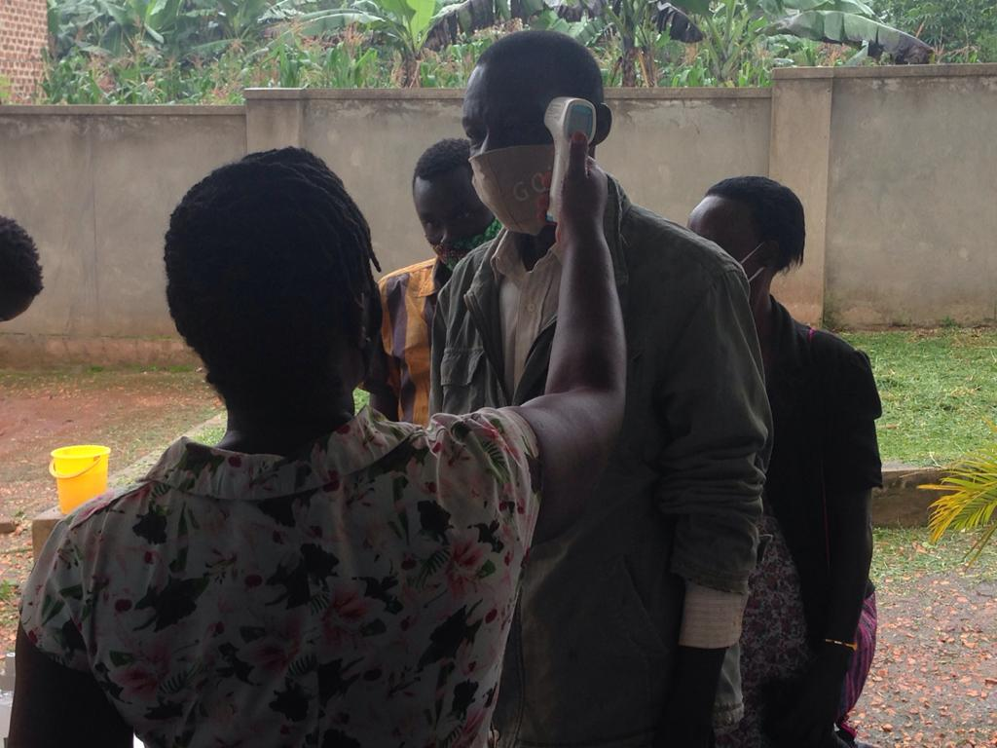
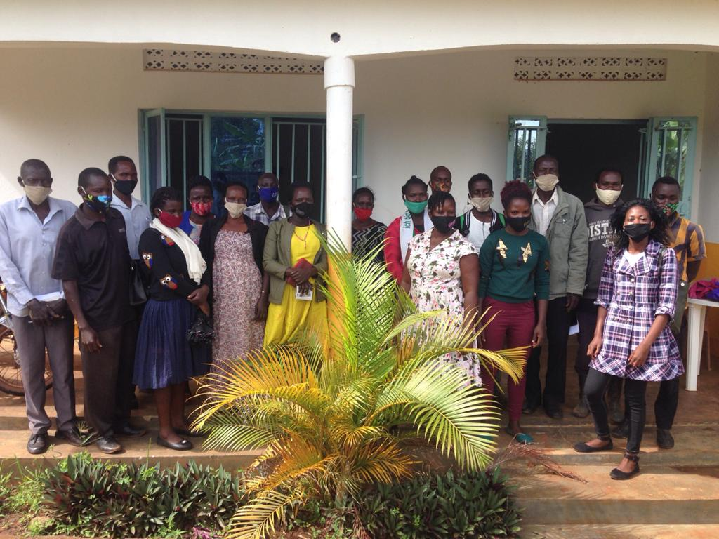

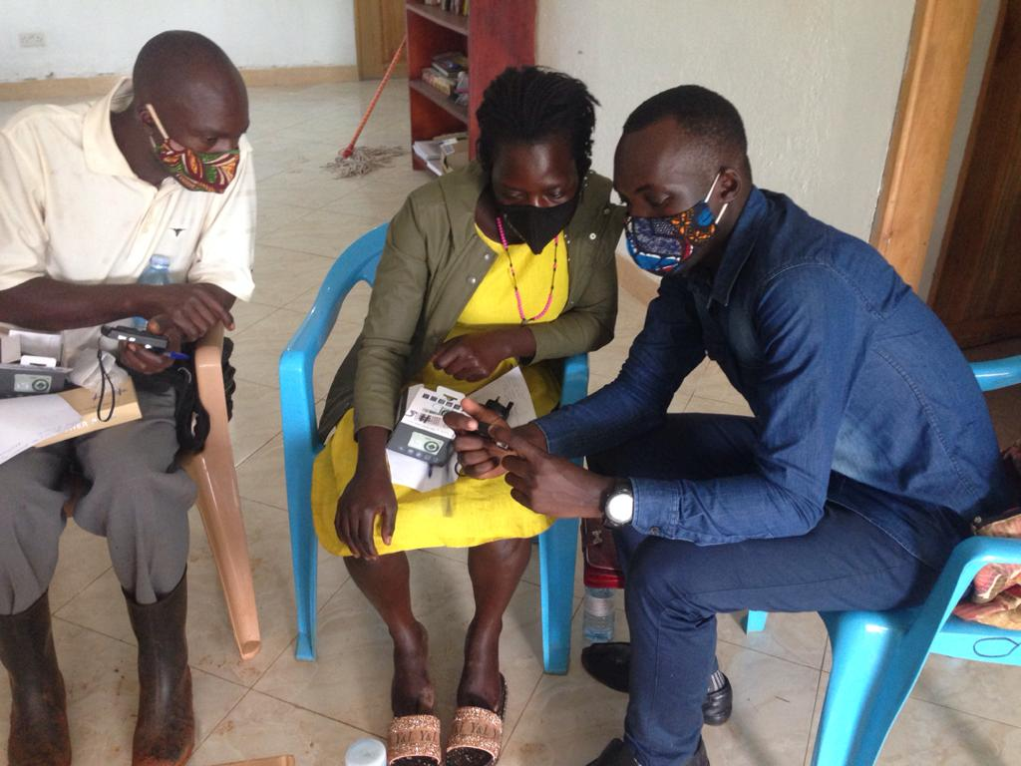
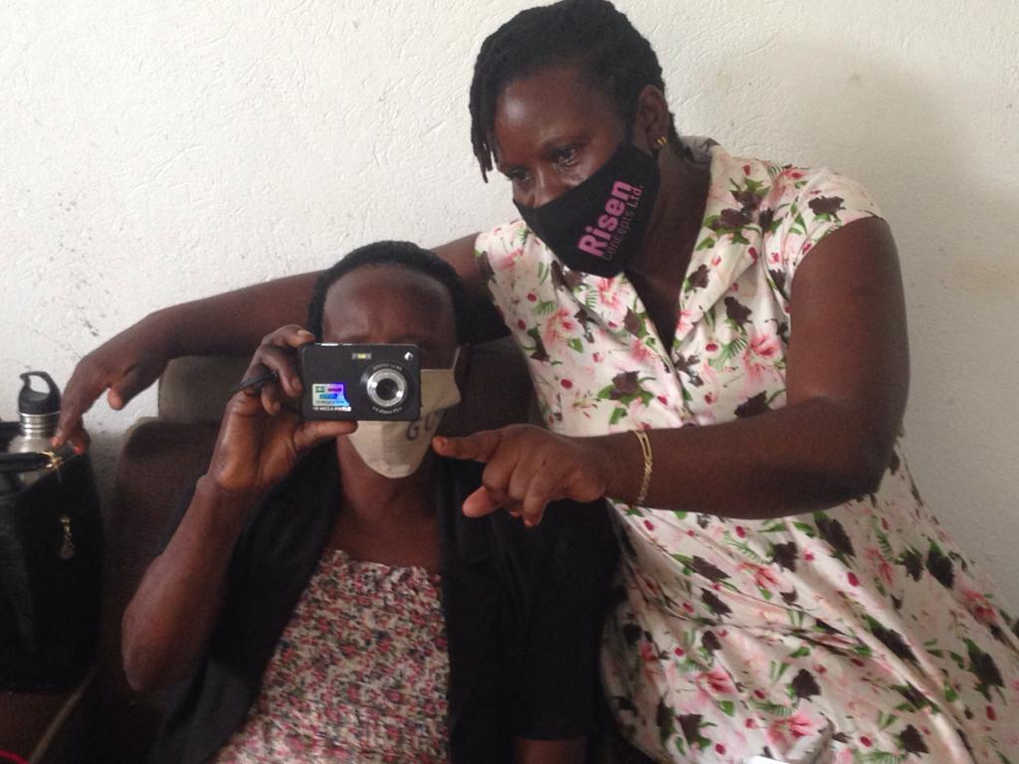

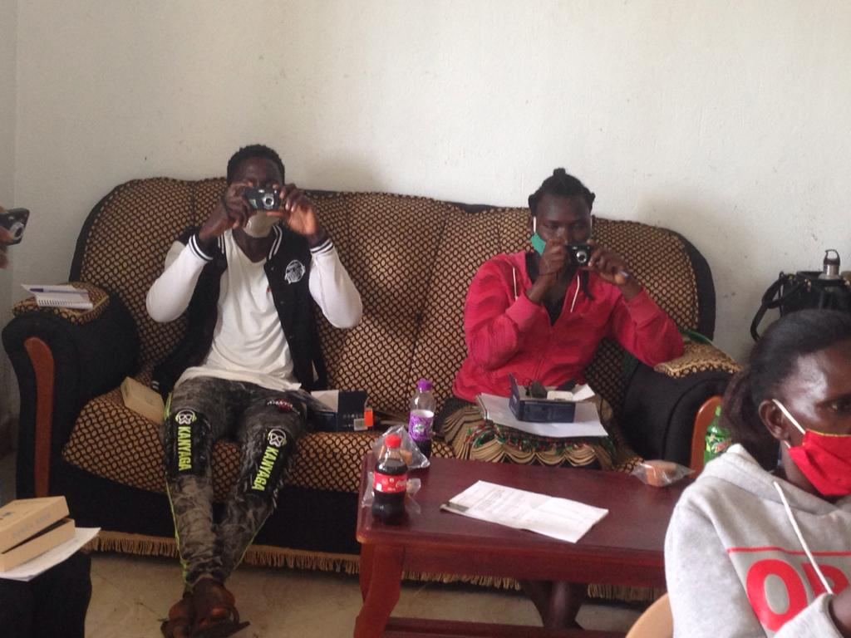

Photographs from top to bottom, left to right: 1. Project participants at the first meeting 2. One of the CHWs involved as a research team member checks a participant’s temperature prior to him entering the meeting room 3. A CHW involved in the project as a research team member explains how to use the camera to one of the project participants 4. One of the Research Assistants shows other community participants how to use their cameras 5. Participants practice using their cameras.

